Application for an MPI-Approved New Vehicle or Machinery system - All Countries

This application form is for manufacturers exporting new vehicles and/or machinery from all countries to New Zealand and wish to have an MPI-Approved New Vehicle or Machinery System. This form also provides guidance around reducing the risk of biosecurity contamination within the vehicle or machinery supply chain.
MPI will evaluate this application and may approve a system based on whether the risk management measures used to prevent biosecurity contamination are appropriate.
If approved, the New Vehicle or Machinery System will be audited by MPI and on-arrival verification activities in New Zealand will occur to ensure the system is effective in ensuring the outcome of MPI’s Vehicle, Machinery and Tyres Import Health Standard (IHS).
An MPI-Approved New Vehicle or Machinery System may be cancelled if it fails to ensure vehicles or machinery arrive in New Zealand free of biosecurity contamination. Biosecurity contamination includes plant material, seeds, soil and live insects or animals as described in the IHS.
Any details obtained for this approval will be kept confidential by MPI and will be used only in assessing criteria for an MPI-Approved New Vehicle or Machinery System.
An application fee of $887.70 NZ applies. This covers the desktop evaluation of the proposed New Vehicle and Machinery System. Additional charges of $102.27 NZ per hour applies for inspection, travel and auditing services in Japan.
For advice or to submit this completed form, please send to Standards@mpi.govt.nz

Contact and Details

Name of Vehicle or Machinery Manufacturer:

Contact Person
Position
Phone
Email
Address

Contact Person in New Zealand
Position
Phone
Email
Address

Exporter Details
- State the approximate annual volume of vehicles or machinery proposed to be exported to New Zealand

- List the type(s) of vehicles and machinery exported to New Zealand. (for example, cars, buses, excavation machinery, farming machinery, trucks, etc.):

Manufacturing Facilities/Sites and Storage of New Vehicles and Machinery
- List the manufacturing sites used for vehicles or machinery exported to New Zealand. Please attach aerial shots of each site location where possible (e.g. google earth).

- State the length of time between manufacture of the vehicles or machinery and departure from the manufacturing site to other destinations.

- Are vehicles or machinery transported from the manufacturing site, directly to the export port? If not, where are vehicles and machinery taken to (please supply address), and for how long before being transported to the export port?
- How are vehicles or machinery transported from the site of manufacture to the export port?

- Are the vehicles transported with used vehicles or other types of new vehicles or machinery?
- How will staff at manufacturing sites, storage or ports areas within the supply chain be made aware of biosecurity contamination including Brown Marmorated Stink Bug (BMSB), Asian Gypsy Moth (AGM), other live insects and plant material and seed risk?

*MPI can provide reference material to assist with awareness. Information around BMSB, AGM and plant material is provided in Appendix 1 - 3.
- Briefly State what measures will be taken to ensure areas of near-by vegetation does not lead to biosecurity contamination of vehicles and machinery.

Note: Please see appendix 5 for methods to control insect risk associated with trees and vegetation close to production and storage sites and appendix 4 for guidance around storage times.
- Please attach any additional resources that explain to MPI the supply chain movements of vehicles or machinery.

Wharf/Port Facilities and Procedures
- List the port(s) used to export vehicles or machinery to New Zealand. Where possible attach an aerial shot of where vehicles or machinery will be stored on the port (google earth).

- Are you aware of any used vehicles or machinery stored in close proximity to your new vehicles or machinery? Please indicate storage area on photo or map.

- Briefly describe the measures that will be taken to prevent possible contamination from other cargo such as used vehicles or machinery in the port area.

- State the maximum length of time that your vehicles or machinery are stored at the port before shipping

- Briefly describe the measures that are carried out to minimise risk of biosecurity contamination during this storage period?

Note: See appendix 5 for expectations based on storage times and appendix 4 for ways to minimise risk during this time.
- Briefly describe the procedure to be followed if biosecurity contamination is found on a vehicle or machine before loading?

Shipping of Vehicles or Machinery
- What shipping lines are used to export your vehicles or machinery?

- Are your vehicles or machinery shipped with only new vehicles or a mixture of new and used vehicles?

- Briefly describe the vessel inspections and cleaning activities of the vessels that are carried out prior to loading vehicles or machinery on the vessel?

- Will the vehicles be transhipped through another country on the way to New Zealand? (Transhipment is the transfer of cargo from one vessel to a port area before loading onto another vessel)
- Do the vessel(s) used to transport vehicle or machinery routinely service the same transportation route? For example, the same route to NZ is repeated without deviation to other ports.

On Arrival Measures

- Are vehicles or machinery taken to a specific place or distribution centre after leaving the discharge port in New Zealand? Please state where.

- What will be done to ensure staff at these centres are aware of the threat of biosecurity contamination associated with vehicles and machinery and be on the lookout for live pests?

*MPI can provide reference material to assist with awareness. Information around BMSB, AGM and plant material is provided in Appendix 1 - 3.

If live contamination is found on vehicles or machinery in New Zealand, contact MPI ASAP: 0800 80 99 66
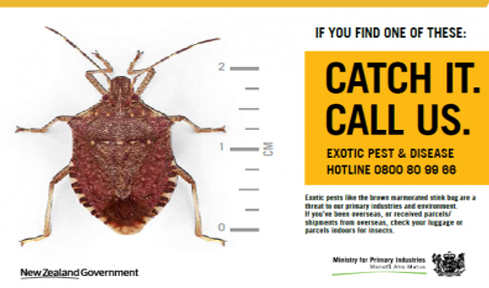

Appendix 1: Brown Marmorated Stink Bug (BMSB)
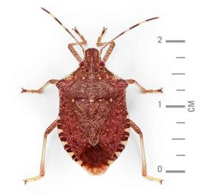
BMSB, also known as Kusagikamemushi in Japan is a pest of great concern to New Zealand. It has been found to be associated with vehicles and machinery from various countries. BMSB is found in some Asian and European countries as well as the USA and more recently in Chile. The bug’s biology causes the bug to seek a suitable place to overwinter during the autumn months (September to November in the northern hemisphere). The bug is known to aggregate (group together) in large numbers in parts of vehicles and machinery. BMSB are known to hitchhike undetected on vehicles and machinery shipped to New Zealand. A new vehicle and machinery system must reduce the risk of BMSB contaminating new vehicles and machinery.

Appendix 2: Asian Gypsy Moth (AGM)
AGM is a serious pest that could cause significant damage to New Zealand’s forestry industry. AGM is found in temperate East Asian countries including China, Japan, the Russian Federation and South Korea. Between June and September the adult female moth may lay eggs on vehicles stored outside. Egg masses are often found around wheels, tyres and wheel arches. These eggs may be shipped undetected and hatch in New Zealand at a later date.
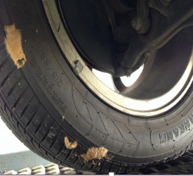


Appendix 3: Plant Material and Seeds
Biosecurity contamination includes plant material such as leaves, flowers, pine needles and seeds. These contaminants can lead to the introduction of unwanted weeds, plants and plant diseases, which can threaten New Zealand’s horticulture and agriculture industries. Plant material can contaminate new vehicles which are stored outside for a period of time. Where possible, new vehicles should not be stored under or very close to trees or vegetation. Monitoring and surveillance should be carried out to prevent and remove plant material contamination prior to export.
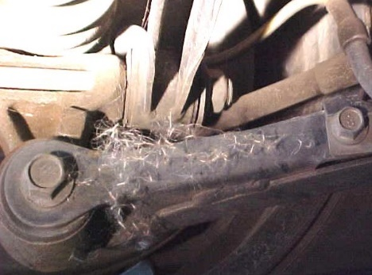
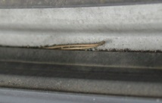
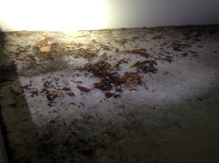

Seeds
Pine Needles
Leaves

Appendix 4: Guidance for Minimising the Risk of Biosecurity Contamination in/on New Vehicles or Machinery
The likelihood of a new vehicle or machine being contaminated can be greatly reduced by various methods. Below are some of the risk reducing measures which can incorporated into a new vehicle or machinery system.
Prevention/Exclusion:
Measures to exclude or prevent pests or plant material from contaminating a vehicle or machine, e.g., inside storage, physical barriers, netting, screens or pest proof packaging.

Reduction/Control:
Effective hygiene, waste disposal and pest management practices to control contamination of vehicles or machines within the supply chain e.g. spraying vegetation, removal of vegetation and removal or spraying of nearby insect nests or aggregations

Monitoring/Verification:
Mechanisms to identify biosecurity contamination risk at various points in the supply chain, e.g. regular surveillance and monitoring of risk areas within the supply chain, especially during risk periods. Monitoring of surrounding areas of vegetation through trapping and visual inspections.

Appendix 5: Storage Periods and Recommended Risk Management Measures

Storage Timeframe | Recommended Measures to Reduce Biosecurity Contamination
Less than 48 hours: | Risk should be managed by regular monitoring for biosecurity contamination at least twice per day.
48 hours to 1 week: | Regular monitoring and additional measures such as:  - Residual spraying with insecticides  - Insect proof nets or covers applied  - Monitoring and management of nearby areas of vegetation.
1 week to 1 month: | Regular monitoring and additional measures such as:  - Inside storage where possible,  - Insect proof nets or covers applied  - Sprayed at regular intervals with a residual insecticide.  - Comprehensive monitoring and management of nearby areas of vegetation.  - Removal of nearby vegetation

Appendix 6: Vegetation associated with Biosecurity Contamination and how to reduce the risk

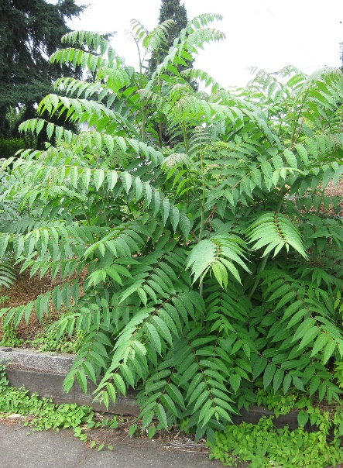
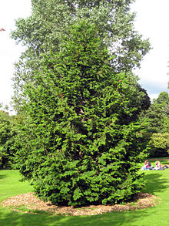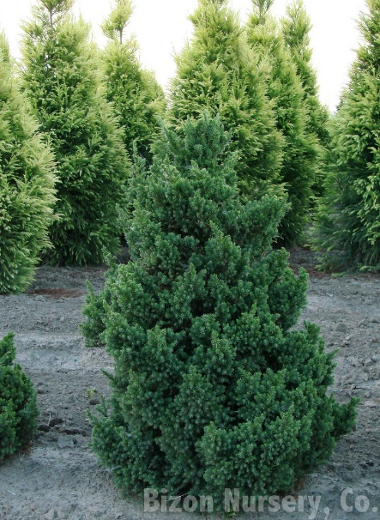
Ailanthus altissima (Tree of Heaven)

Cryptomeria japonica (Japanese cedar)
Chamaecyparis obtusa (Hinoki cypress),

The tree species above, along with hundreds of other plant species are often associated with BMSB which are known to contaminate vehicles and machinery at certain times of the year. Any vegetation surrounding areas where new vehicles are stored, should be monitored for BMSB from April to September using pheromone traps (for example, Trece^{tm} traps or lures (below)) and by visual inspection of the surrounding vegetation.
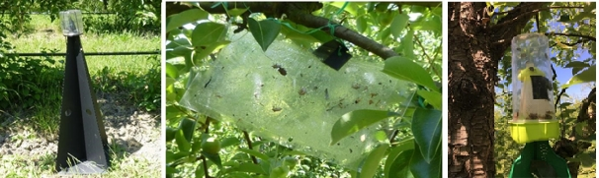
Pheromone traps (middle) use pheromones to attract bugs and are especially good at indicating if BMSB are present in surrounding vegetation during the summer months. If BMSB are discovered in traps or by searching vegetation, the area should be sprayed from late July to the end of September. This will help prevent BMSB leaving the areas of vegetation and over-wintering in/on vehicles or machinery stored nearby before being exported to New Zealand. If necessary, spraying should be carried out with a broad spectrum residual insecticide. The pyrethroids permethrin and bifenthrin have been demonstrated to be effective against BMSB and remain effective over a seven day period.

Appendix 7: Internal Audit Check List for New Vehicle or Machinery System

Use the following checklist to help ensure your MPI Approved New Vehicle or Machinery System is compliant with the processes and procedures approved by MPI. Internal checks should occur at least once a year shortly before the high risk BMSB period starting in September.

Name: | Date: Click here to enter a date.

Manufacturing sites and operation | Y / N | Objective evidence
- Are staff involved with the supply chain aware of biosecurity contamination risk especially BMSB risk? |  | Procedures known and available to staff?  Any training for new staff?
- Are the documented monitoring procedures for reducing the chance of BMSB and other biosecurity contamination being followed? |  | For example, regular monitoring?  Insecticide spraying  Advanced storage conditions/netting?
- Are risk management measures around nearby vegetation being followed? |  | Procedures known and available to staff?  On a regular basis?  Spraying and trapping?  Residual insecticide programme?
- Has any contamination been recorded or reported at the site(s)? |  | Contamination logs/records?
Transportation | Y / N | Objective evidence
- Are vehicles transported as per your outlined procedures? |  | Procedures known and available to staff?

Port Storage | Y / N | Objective evidence
- Are the procedures around regular vehicle monitoring being followed? |  | Procedures known to all staff?
- Has any contamination been recorded or reported at the wharf site(s)? |  | Contamination logs/records?
- Have any wharf procedures or locations changed after MPI Approval was given? |  | Change to storage area? New risks to be managed?
- Are vehicles being shipped in the timeframes outlined? What occurs if timeframes are exceeded? |  | Contingency plan?  Notify MPI?
Shipping | Y / N | Comments
- Are procedures for shipping outlined and followed? Are all port staff aware of these procedures during loading? |  | Stevedores aware of procedures and BMSB?
- Are shipping lines staff aware of biosecurity requirements? |  | Sufficient knowledge of biosecurity contamination risk?
- Are contaminated vehicles refused loading, or managed in some way prior to loading? |  | Are further inspections done?
- Are vessel inspections undertaken prior to loading of vehicles? |  | Who is completing inspections and how?

Items to follow up (use numbers) | Date resolved
 | Click here to enter a date.
 | Click here to enter a date.

