（別紙様式８－１ 輸出検疫証明書様式（牛肉））
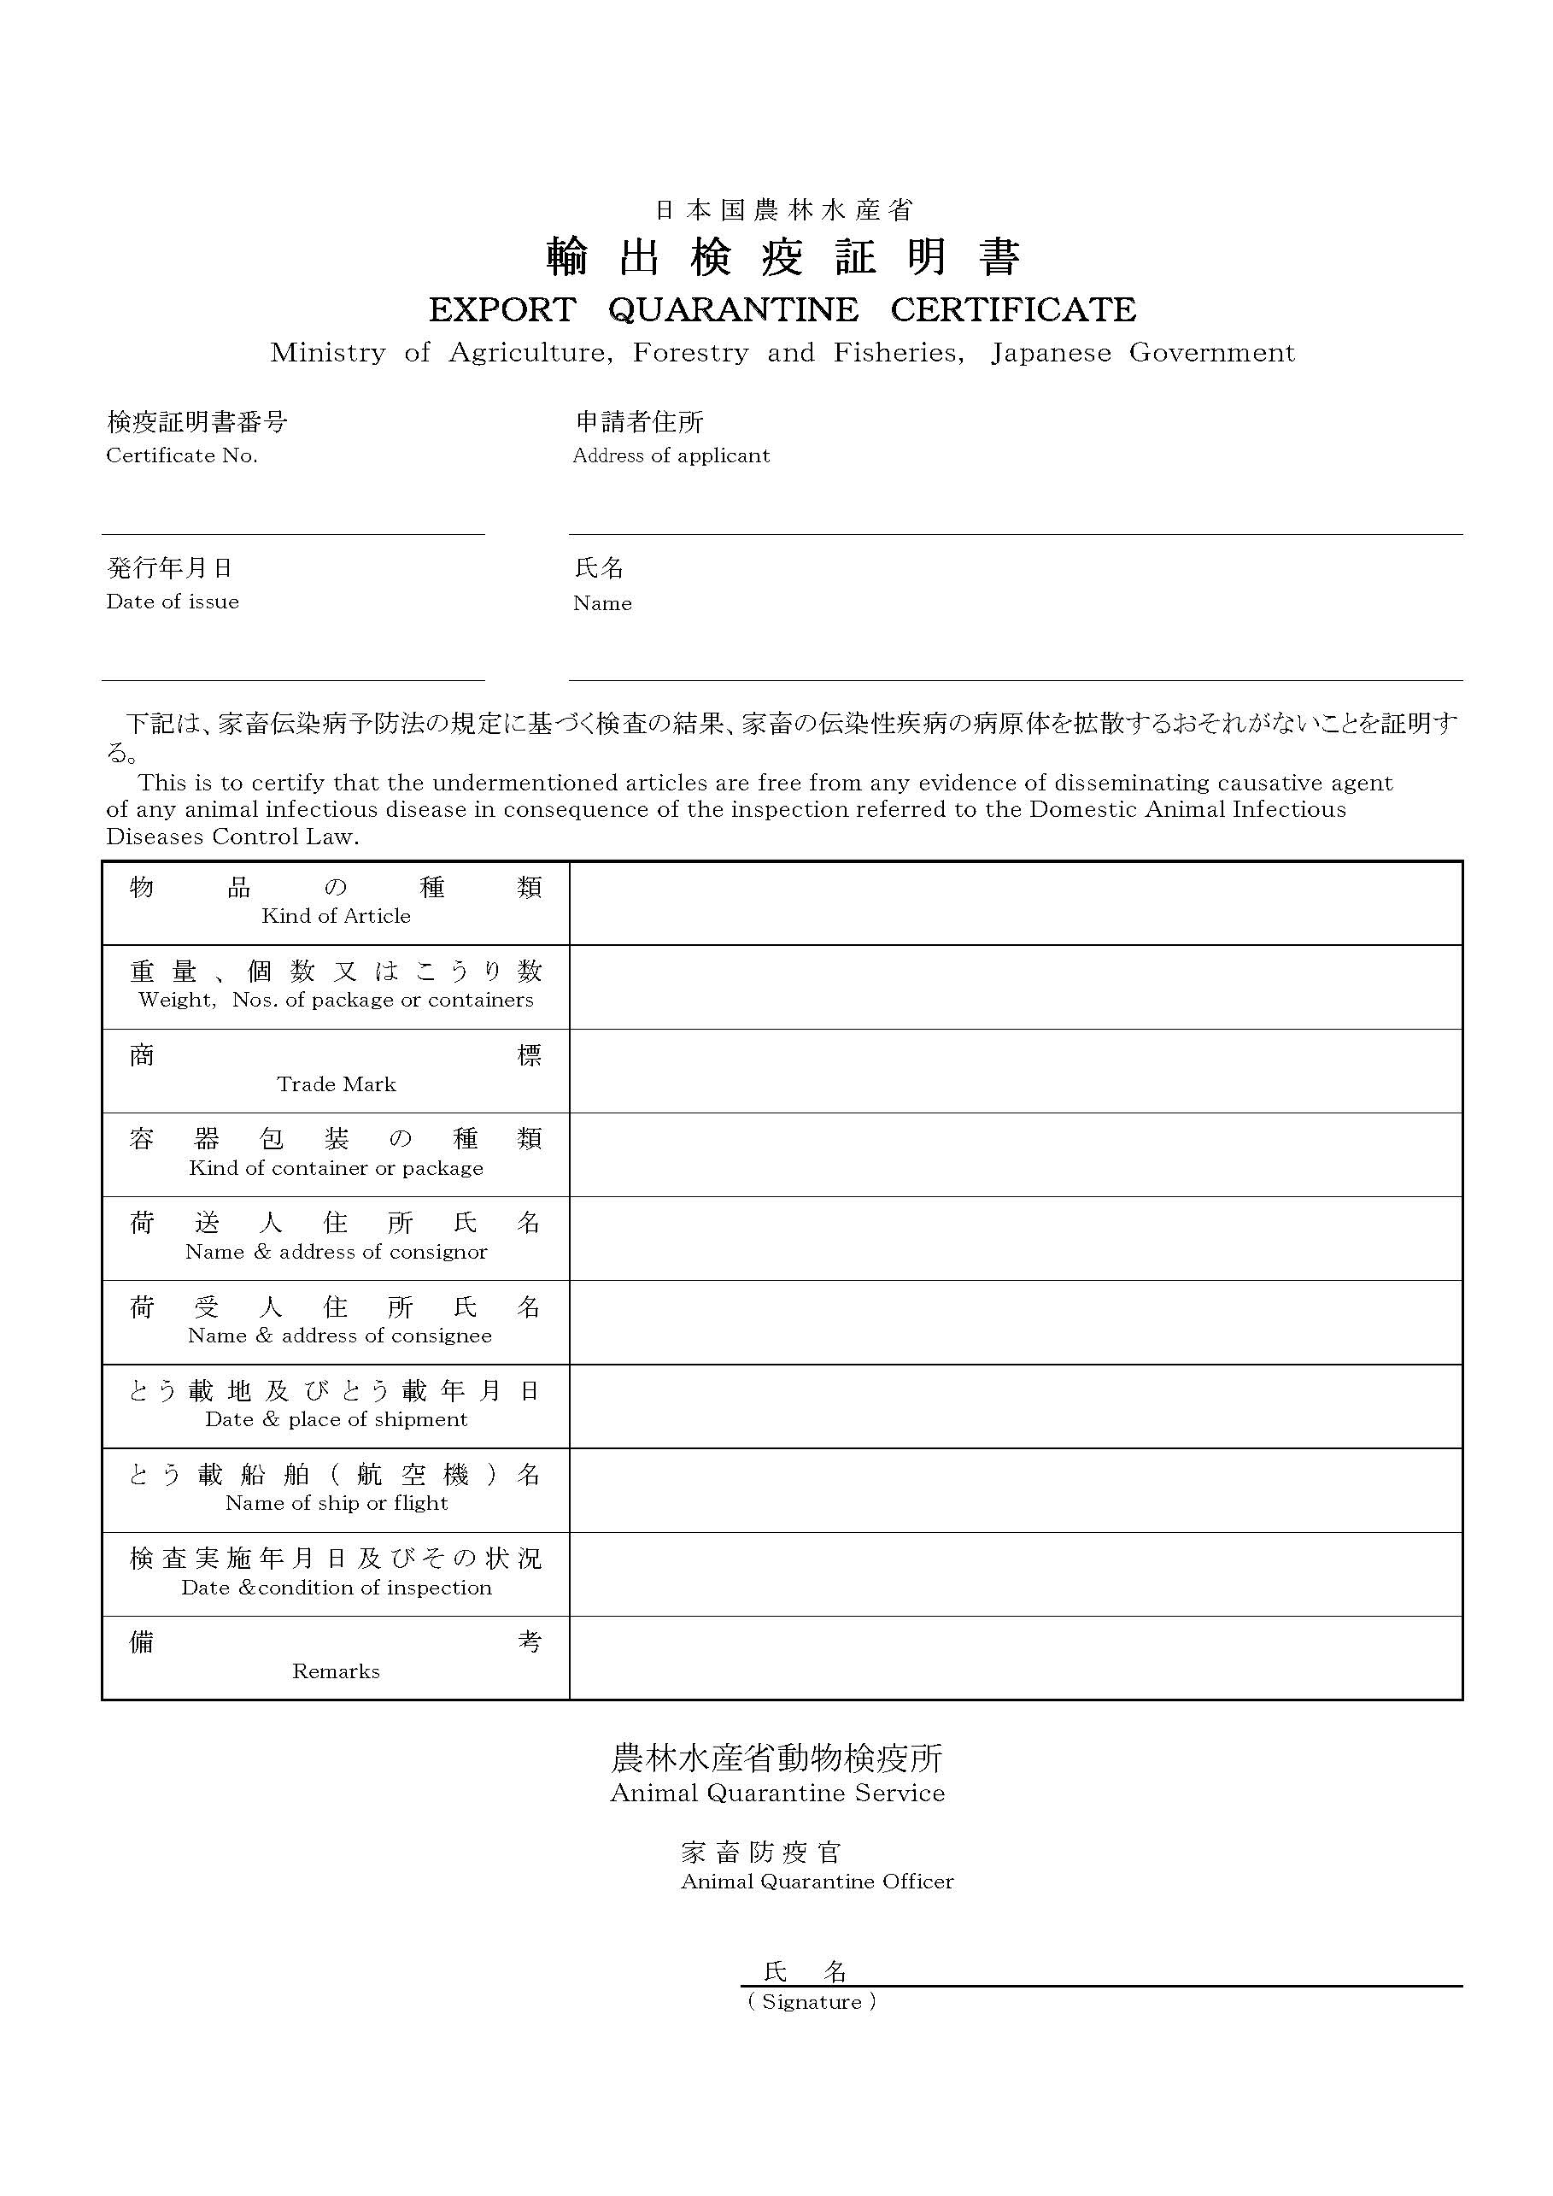
Attached export quarantine certificate for beef and beef products
to be exported to Singapore from Japan
No.
I, the undersigned official veterinarian, certify that;
- Japan is free from Foot-and-Mouth Disease (FMD) without vaccination, as officially recognized by the OIE.
OR
The beef and beef products have been processed by heat treatment that is sufficient for inactivation of FMD virus in accordance with OIE guidelines.
- Japan is recognized by the OIE as having negligible BSE risk according to Resolution No. 20 of the 81th General Session in May 2013, satisfying the conditions in Chapter 11.5 of the Terrestrial Animal Health Code.
- The beef and beef products were obtained from cattle which were born and raised in Japan since birth.
OR;
The beef products have been prepared from beef which originated from establishments in the third countries/regions authorized by the Singapore Food Agency (SFA), and are not suspended or subjected to zonal restriction imposed by the SFA from exporting to Singapore.
- The beef and beef products have been inspected by Officials from the Ministry of Agriculture, Forestry and Fisheries (MAFF).
Animal Quarantine Service
Ministry of Agriculture, Forestry and Fisheries
Japanese Government
Animal Quarantine Officer
OFFICIAL STAMP
Signature:
(Printing Name)

（別紙様式８－２ 輸出検疫証明書様式（豚肉））

Attached export quarantine certificate for pork and pork products
to be exported to Singapore from Japan
No.
I, the undersigned official veterinarian, certify that;
- African Swine Fever (ASF) and Classical Swine Fever (CSF) are notifiable diseases in Japan.
- Japan has been free from Foot-and-Mouth Disease (FMD) without vaccination and ASF for three months immediately prior to the date of slaughter of the animals and the date of export. The FMD status without vaccination is officially recognized by the WOAH.
OR;
The pork products have been processed by heat treatment that is sufficient for inactivation of FMD and ASF virus in accordance with WOAH guidelines.
- Japan has been free from CSF for three months immediately prior to the date of slaughter of the animals and the date of export.
OR;
The pork and pork products are not derived from pigs originating from prefecture where CSF has occurred or vaccination against CSF is practiced.
Origin of pigs:
OR;
The pork products have been processed by heat treatment that is sufficient for inactivation of CSF virus in accordance with WOAH guidelines or that Japan considers as equivalent treatment based on the relevant documents submitted by the applicant.
- The pork and pork products were obtained from pigs which were born and raised in Japan since birth and which have not been swill-fed.
OR;
The pork products have been prepared from pork which originated from establishments in the third countries/areas authorized by the Singapore Food Agency (SFA) and are not suspended or subjected to zonal restriction imposed by the SFA from exporting to Singapore.
- The pork and pork products have been inspected by officials from the Ministry of Agriculture, Forestry and Fisheries (MAFF).
Animal Quarantine Service
Ministry of Agriculture, Forestry and Fisheries
Japanese Government
Animal Quarantine Officer
OFFICIAL STAMP
Signature:

（別紙様式９ Particular Informations of Establishment (Beef and Pork)）
PARTICULARS OF ESTABLISHMENT
(1) Name of Establishment
(2) Establishment Number
(3) Address of Establishment
Unit No.
Street Name
Post Code
District/City
State/Province
(4) Products Intended for Export to Singapore
Meat cuts | List products and state form* (chilled/frozen):  (i) e.g. whole chicken with giblets (frozen) / beef cuts (frozen/ chilled)  (ii)  (iii)
Offal | List products and state form* (chilled/frozen):  (i) e.g. pig heart (frozen)  (ii)  (iii)

SINGAPORE IMPORTER INFORMATION
Indicate if contact with Singapore importers has been established
Yes, please provide the following information.
No
Name of importing company in Singapore
Name and designation of correspondent
Business Address
Telephone / Mobile
Email address

SALES CONTACT INFORMATION
Please provide the contact details of the Sales Department. This contact point would be provided to interested Singapore importers.
Name and designation of sales contact person
Office address (if different from the establishment address)
E-mail address
Telephone / Mobile
- 英語で記入すること。
（別紙様式10 条件付き認定に係る変更の申請（施設））
年 月 日

厚生労働大臣 殿

申請者 住所
氏名
法人にあってはその名称、所在地及び
代表者氏名

シンガポール向け輸出食肉取扱施設の条件付き認定に係る変更の申請書

「シンガポール向け輸出食肉の取扱要綱」に基づき、下記の製品の輸出について関係書類を添えて申請します。

記

１ 認定と畜場等の名称及び所在地

２ 新たに輸出しようとする製品

３ 添付資料
・新たに輸出を希望する製品に係る書類（標準作業手順書等）

（別紙様式11 変更又は認定取下げ届（施設））
年 月 日

厚生労働大臣 殿

申請者 住所
氏名
法人にあってはその名称、所在地及び
代表者氏名
変 更
・
認定の取下げ

シンガポール向け輸出食肉取扱施設の に係る届出

「シンガポール向け輸出食肉の取扱要綱」に基づき、下記の認定と畜場等の申請事項の変更又は認定の取下げについて届け出ます。

記

１ 認定と畜場等の名称及び所在地

２ 認定事項変更の場合、変更事項

３ 変更・認定取下げ理由

４ 変更・認定取下げ年月日

５ 添付資料

（別紙様式12 検査体制の変更届（食肉衛生検査所等））
年 月 日

厚生労働大臣 殿

都道府県知事等名

シンガポール向け輸出食肉取扱施設の検査体制の変更に係る届出

「シンガポール向け輸出食肉の取扱要綱」に基づき、下記の認定と畜場等の検査体制の変更について、関係書類を添えて届け出ます。

記

１ 認定と畜場等の名称及び所在地、食肉衛生検査所等の名称及び所在地

２ 変更事項

３ 変更理由

４ 変更年月日

５ 添付資料

（別紙様式13 Notification of change from Establishment (Beef and Pork)）
Before
PARTICULARS OF ESTABLISHMENT
(1) Name of Establishment
(2) Establishment Number
(3) Address of Establishment
Unit No.
Street Name
Post Code
District/City
State/Province
(4) Products Intended for Export to Singapore
Product name |  | Species | State (Chilled/Frozen)

After
PARTICULARS OF ESTABLISHMENT
(1) Name of Establishment
(2) Establishment Number
(3) Address of Establishment
Unit No.
Street Name
Post Code
District/City
State/Province
(4) Products Intended for Export to Singapore
Product name |  | Species | State (Chilled/Frozen)

- 英語で変更箇所が分かるように記載すること。

